1. Write a program to style content using different CSS selectors?

Expected Output:

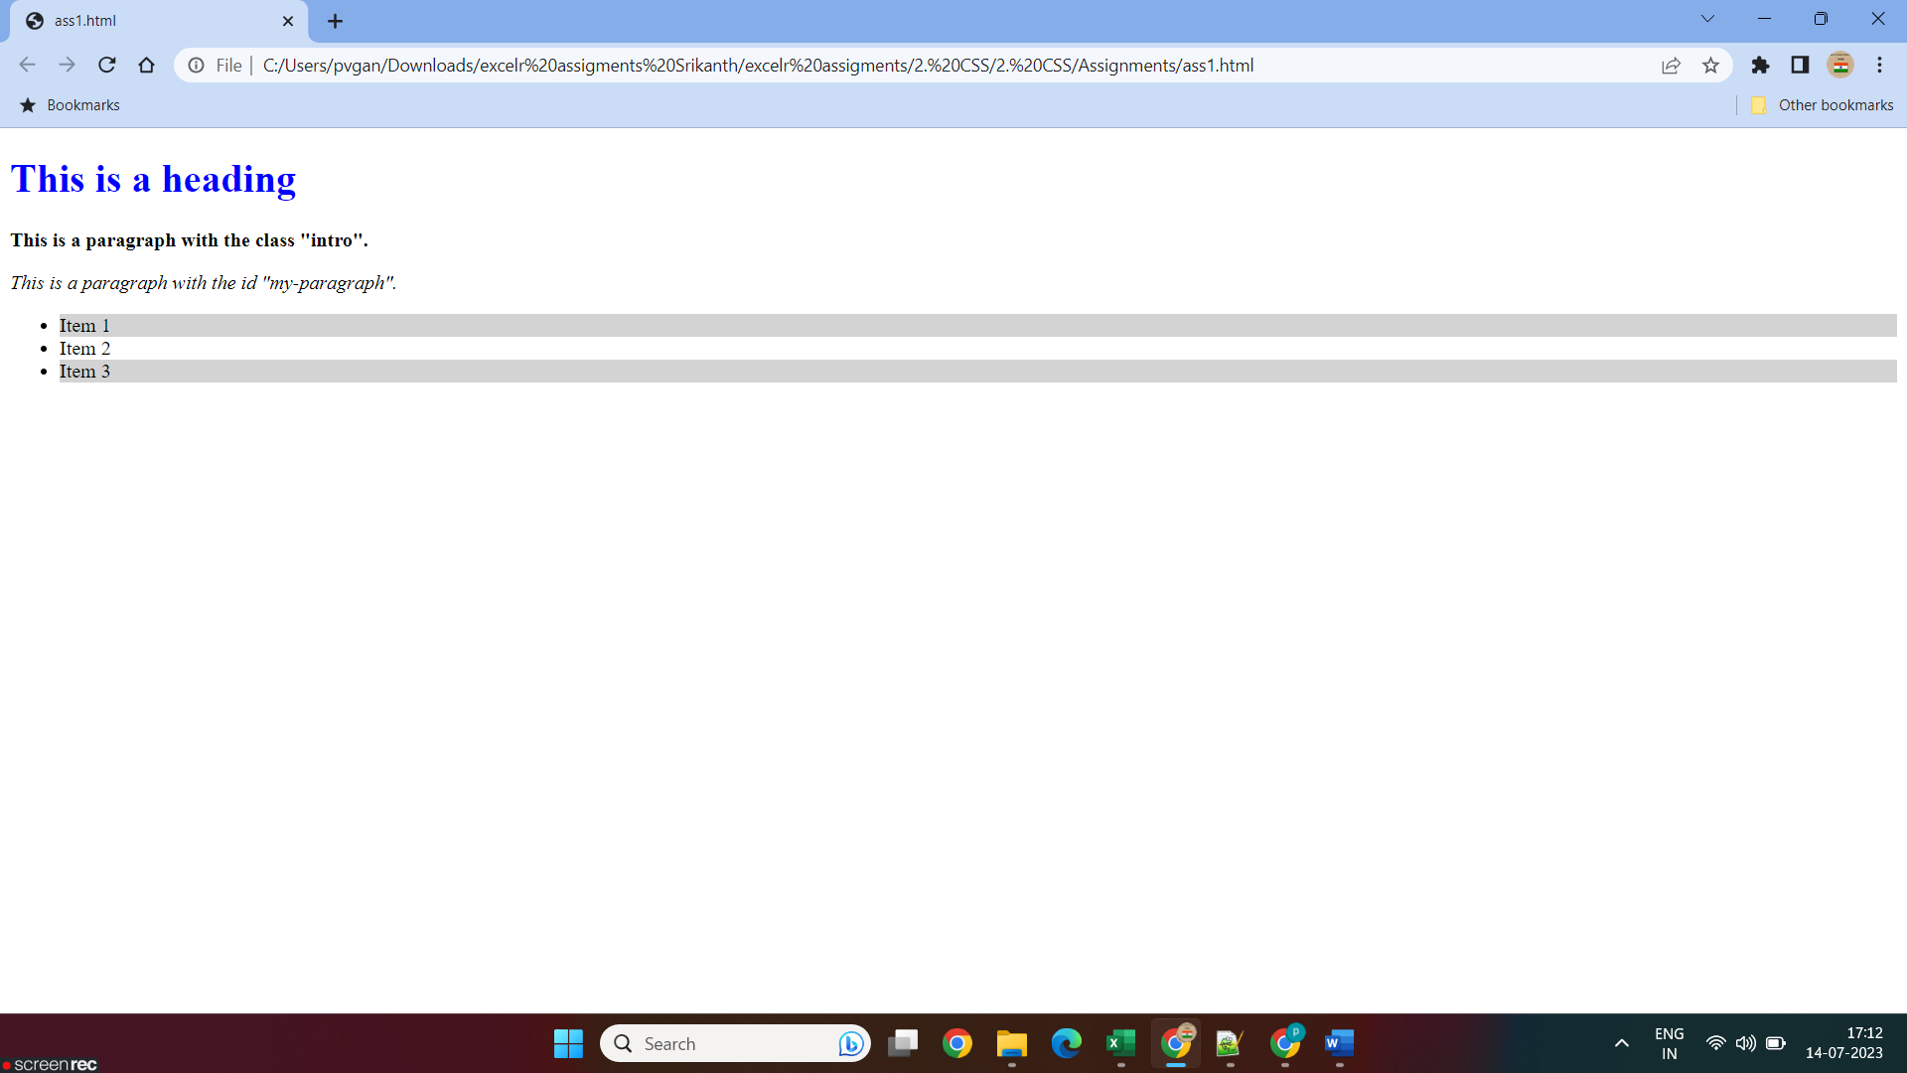

1. Write a program to show different background properties and display course information using different font properties in css?

 pattern.png  image.jpg

Expected Output:

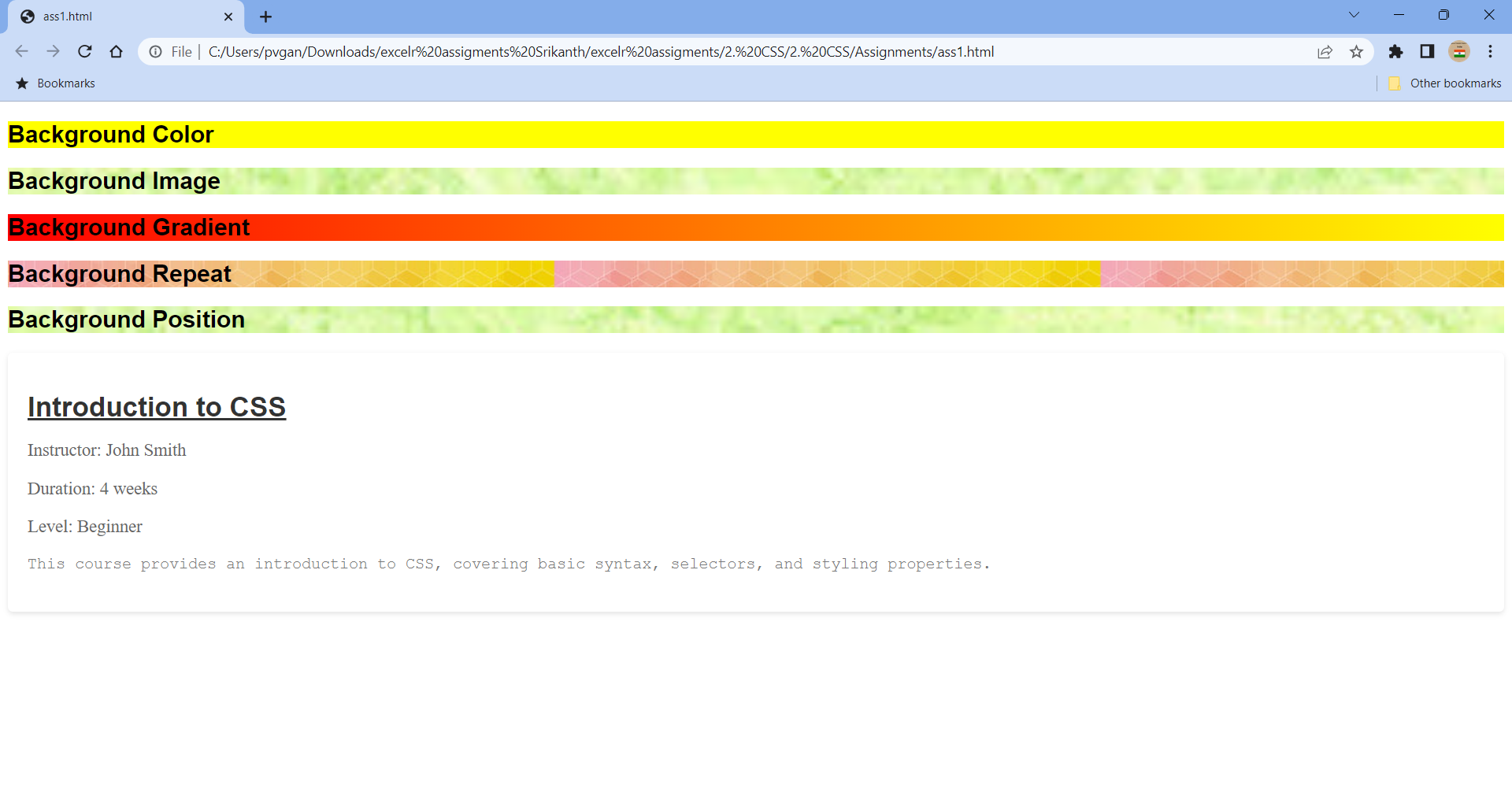

1. Write a program to display courses in a tile using flexbox?

Expected Output:

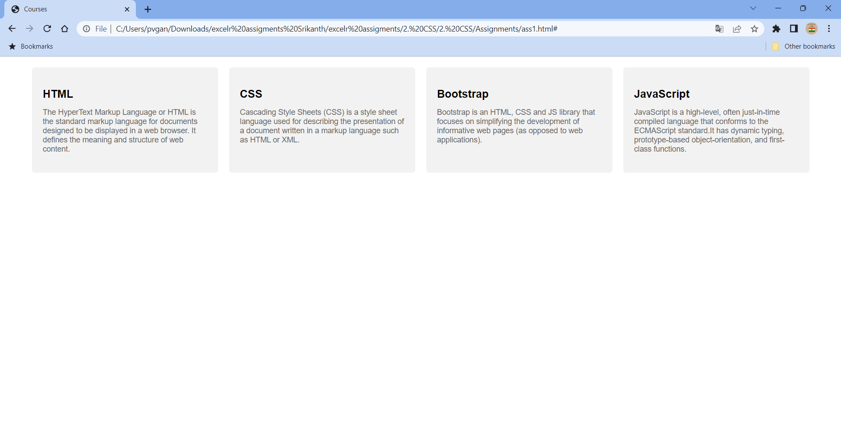

1. Write a program to design standard web layout using GRID?
2. Write a program to create responsive menu using media queries css?
3. Write a program to animate a tile in CSS?